Identity verification always poses a challenge in identity management in web3 communities due to Sybil attack, Sybil attack involves individuals creating and faking multiple accounts to gain access and take advantage of opportunity created for multiple anon.

Let’s explain gitcoin, ceramic, and passport in details before analyzing the gitcoin passport.

What is gitcoin?

[Gitcoin (GTC)](https://gitcoin.co/) is an Ethereum token that enables community governance of the Gitcoin platform. The platform is designed to fund and coordinate open source development by novel means such as quadratic funding. As of June 2021, Gitcoin has facilitated over $21 million in grants and bounties for open source developers.

Gitcoin is a platform where coders and developers can get paid to work on open-source software in a wide variety of programming languages. Users can also submit their own project ideas to the Gitcoin platform in order to crowd source funding from contributing donors. Aside from direct community crowd funding, Gitcoin employs a unique system known as quadratic funding to help match community funding efforts to accelerate development of the projects the community deems most popular. All in all, Gitcoin is a platform designed to foster the development of meaningful, open-source projects and better align the interests of donors and developers.

From an ideological standpoint, Gitcoin believes that [open-source](https://www.gemini.com/cryptopedia/glossary#open-source) software is an integral cornerstone of software development and modern computing at large. Launched in November 2017, the Gitcoin crypto platform seeks to foster collaboration on open-source software projects. It achieves this by incentivizing developers to take on development projects with reward payments and grants. Many developers who contribute to open-source projects do so with little to no direct compensation because the software is by nature free and open but Gitcoin was created to help compensate developers who want to contribute to meaningful open-source software applications.

The Gitcoin platform focuses on funding “public goods” projects, which are typically “non-rivalrous” and “non-excludable” in other words, they are designed to benefit everybody without necessarily competing with one another. Examples of public goods projects include those related to clean air, infrastructure, and privacy. However, most of the public goods projects funded by Gitcoin include projects that address blockchain within the [Ethereum](https://www.gemini.com/cryptopedia/ethereum-blockchain-smart-contracts-dapps) ecosystem. For example, there are ongoing projects to translate Ethereum’s source material into different languages, to accelerate Gitcoin’s transition to full [decentralization](https://www.gemini.com/cryptopedia/glossary#decentralized-decentralization), and to support educational content creators.

Gitcoin seeks to encourage talented developers to join the platform by offering a financial incentive to participate in [hackathons](https://www.gemini.com/cryptopedia/glossary#hackathon), [bounties](https://www.gemini.com/cryptopedia/bounty-program-crypto-bounty-campaigns-hack-bounty), and funded community grants. Developers who have a project they wish to work on can submit it on the Gitcoin platform and crowd source funding directly from other contributors, as well as participate in quarterly opportunities to earn extra funding through the platform’s innovative quadratic funding mechanism.

## Quadratic Funding and Gitcoin Crypto Grants

Gitcoin crypto funding is directed to public goods projects through a proprietary, democratic system known as quadratic funding. Quadratic funding is a structure for crowd funding campaigns where donations from individuals are matched with corresponding amounts of funding from larger pools of funds supplied by bigger donors. Funds are not “matched” according to a 1:1 ratio, but rather according to a proprietary formula. The formula is optimized to reward projects with more community support. So, for example, if a grant receives 100 individual donations of $1 USD, it would receive more in matched funds than a grant that received one donation of $100.

Quadratic funding is intended to align the needs and incentives of donors, those seeking funding to carry out public goods projects, and developers. Through quadratic funding, small donors are able to support what they deem to be the best public goods projects, and by doing so drive up matched funding. Similarly, developers with an objective they want to work on may leverage quadratic funding on the Gitcoin platform to finance their own projects. Users who submit their own grants must draft a clear project title and description, and specify if they’d like contributors to donate funds in a particular [ERC-20 token](https://www.gemini.com/cryptopedia/erc20-token-standard-ethereum) (Gitcoin supports all ERC-20 tokens).

Currently, the quadratic funding matching pools are funded primarily by user donations to the Gitcoin Grants official matching pool fund, although other matching pools exist and more will likely continue to be created. Users can contribute funds to matching pools, which are then proportionately doled out to popular projects according to the quadratic funding formula with matching rounds occurring quarterly. As of October 2021, Gitcoin Grants have funneled approximately $35 million towards open-source public goods projects, including about $5 million in specialized “bounty” projects — another way for developers to earn on Gitcoin.

What is ceramics?

The Gitcoin Passport is an identity verification application on the Ceramic Network. Ceramic is an off-chain sovereign data network mapping decentralized identifiers (DIDs) to streams of user-controlled data. Data on Ceramic is public, permissionless, and verifiable, unlocking information access and interoperability between all platforms and services across the web. Using Ceramic, we have written software enabling people to grow personal collections of [verifiable credentials](https://decentralized-id.com/web-standards/w3c/wg/vc/verifiable-credentials/) about themselves and organizations to assess their identities to coordinate rights and responsibilities. Organizations define, verify, and utilize identity as functions of the networked records of the individuals. While we build the Passport agnostic to specific applications, we are actively exploring its benefits for [personhood proofs](https://en.wikipedia.org/wiki/Proof_of_personhood) and [plurality](https://www.radicalxchange.org/media/blog/why-i-am-a-pluralist/) in organizational designs.

Ceramic is a public, permissionless, open source protocol that provides computation, state transformations, and consensus for all types of data structures stored on the decentralized web. Ceramic's stream processing enables developers to build with dynamic information without trusted database servers to create powerful, secure, trustless, censorship-resistant applications.

The Ceramic Network is a decentralized, worldwide network of nodes running the Ceramic protocol that communicate over a dedicated topic on the Libp2p peer-to-peer networking protocol. Ceramic is able to achieve maximum horizontal scalability, throughput, and performance due to its unique design.

What is passport?

**passport**, a formal document or certification issued by a national government identifying a traveler as a citizen or national with a right to protection while abroad and a right to return to the country of [citizenship](https://www.britannica.com/topic/citizenship).

Passports, letters of [transit](https://www.britannica.com/dictionary/transit), and similar documents were used for centuries to allow individuals to travel safely in foreign lands, but the adoption of the passport by all countries is a development of the 19th and 20th centuries. A passport is a small booklet containing a description of the bearer and an accompanying photograph that can be used for purposes of identification. Many countries require travelers entering their borders to obtain a visa i.e., an endorsement made on a passport by the proper authorities denoting that it has been examined and that the bearer may proceed. The visa permits the traveler to remain in a country for a specified period of time. By the late 20th century the demands of [tourism](https://www.britannica.com/topic/tourism) had prompted several countries in western Europe to relax their travel regulations so that travelers could move between them without visas or, in some cases, even without passports. (This arrangement has since expanded to include most countries within the [European Union](https://www.britannica.com/topic/European-Union).) At the same time, many countries around the world, to prevent [fraud](https://www.britannica.com/dictionary/fraud), have added to their passports security features such as holograms, digital watermarks, and embedded microchips that store biometric data.

GITCOIN CERAMICS PASSPORT

Despite the benefits of cloud services, SaaS tools, and API businesses, building a fully featured product or service is still extremely complex, fragile, and limited. Even simple apps require deploying and maintaining a backend, securing and managing user identities and data, and tying together a tangle of APIs and services. Choices made early often lock developers in to long term relationships with technology providers, which vendors exploit. Making a product’s value-add interoperate with other products and services is often difficult and unpredictable. All of this is because infrastructure, information, and access control are needlessly replicated and siloed for each individual application.

To combat these problems of duplication, fragmentation, and insecurity, the internet needs a flexible public infrastructure where participants can store verifiable information that is universally discoverable and accessible across all applications. By keeping identifiers, their associated data, and services in the public domain instead of on siloed application servers, they can be accessed by all participants across the web. In this model, participants directly define and control their resources, share (or not) these resources with others, and bring their identities and metadata across experiences.

In addition to giving users more agency and control, this model dramatically simplifies the experience for developers as well. Instead of spending effort on managing data and tying together various services, developers can focus on the value-add in their product. Each application can simply query an identity for the information and access they need. Data can be easily shared across products without compromising privacy. Experiences can be composed in real-time to user’s preferences. Bilateral service signups and agreements can be done away with, replaced instead by frictionless payment channels for services.

All of this frees products and services from needing to perform non-critical functions, reconciling services and data, worrying about user trust and liability, or scrambling to attract and retain users through many points of friction. Instead, developers can simply build a product that plugs into an already existing ecosystem of users, data, and services that work seamlessly together. Over time, this will result in more targeted micro-services and micro-applications being developed, instead of the behemoths we see today.

## Requirements

The composable web needs a permissionless, identity-centric interoperability protocol to provide applications with all the information they need to easily discover, route to, gain access to, and interact with a user’s resources regardless of which wallet users bring, which applications created the data, or where the resources are located. This protocol must:

1. Permissionlessly register an interoperable identity (DID);
2. Privately control this identity with multiple private keys;
3. Publicly associate public keys and accounts to this identity;
4. Publicly or privately associate resources to this identity;
5. Set permissions for resources;
6. Perform access control to resources;
7. Interoperably sign and/or encrypt information; and
8. Revoke private keys, public keys, and permissions for resources.

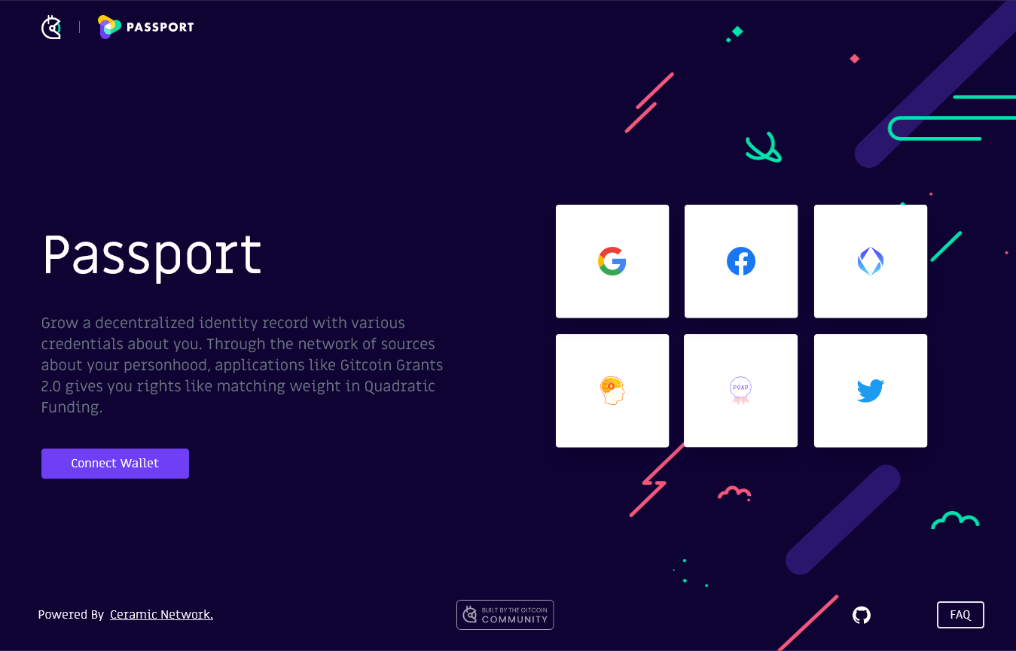

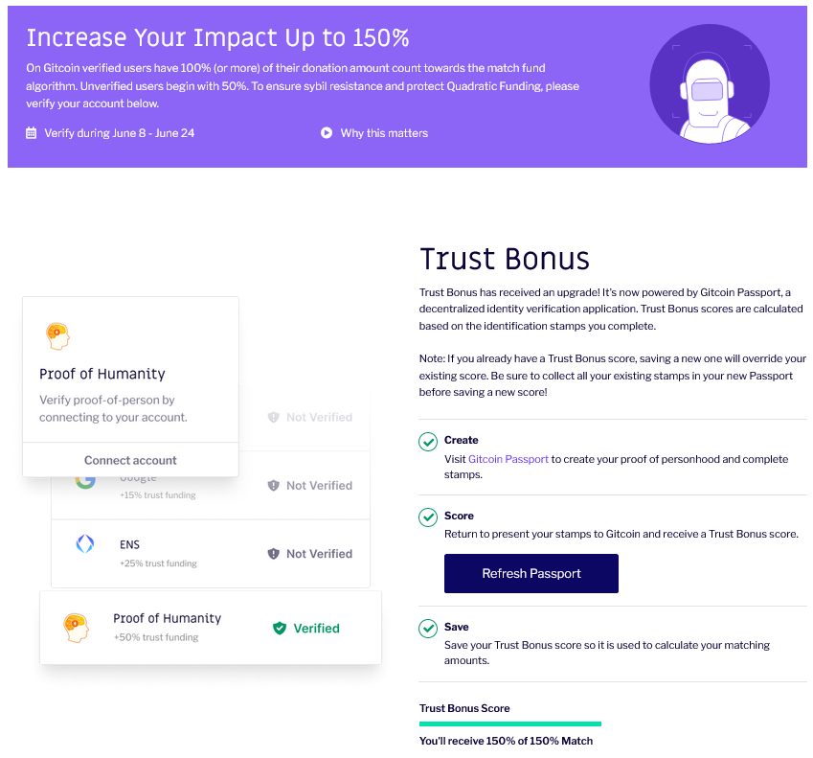

Ceramic is passionate about creating easy-to-use building blocks for Web3 data. That’s why they partnered with Gitcoin, a team that shares a similar vision. [Gitcoin](https://gitcoin.co/) is on a mission to empower builder communities to build and fund public goods. Today, they launched Gitcoin Passport as a decentralized identity verification utility, using Ceramic to store personal credentials and make them portable across ecosystems.

Gitcoin adopts this new application as part of the active Grants Round 14 to verify the unique personhood of contributors in the Quadratic Funding matching program. If you're contributing to Gitcoin Grants, go to the Trust Bonus page in your profile or [Gitcoin Passport](https://passport.gitcoin.co/#/dashboard) to verify your unique personhood and, in turn, increase your matching.

### What is Gitcoin Grants?

Gitcoin Grants is the largest Quadratic Funding application in the Web3 space, processing over $1.5mm/quarter in funding for a variety of hackathons, bounties, and open source projects. Quadratic Funding is the [mathematically optimal way](https://wtfisqf.com/) to fund public goods in a democratic community.

During every grants round, projects undergo a crowd funding campaign that is matched with funds according to the Quadratic Funding algorithm, where the number of contributors matters more than amount funded. This pushes power to the edges and away from whales who may have simply donated a much higher amount. In public goods funding, this ultimately creates more democracy.

### The Importance of Sybil Resistance and the Trust Bonus

While Quadratic Funding is the most optimal way to democratically allocate funds to projects that a community cares about, [it is susceptible to Sybil attacks](https://support.gitcoin.co/gitcoin-policy/policy/understanding-potential-attack-vectors/sybil-attack). In Gitcoin Grants, the Sybil attack means that a user spreads their funds across multiple wallets and donates to the same project. Since Quadratic Funding weighs the number of donations over the total amount donated, attackers can game the system to receive a larger slice of the QF matching pool.

To build in Sybil resistance, the Gitcoin team asks users to verify their “proof of humanity” by proving ownership over various accounts and data. Gitcoin Grants integrates with a variety of identity providers (Proof of Humanity or BrightID), Web2 services (Google, Twitter, or Facebook), and Web3 accounts (ENS). Users who verify their identity through a number of these mechanisms are eligible for a ‘Trust Bonus,’ allowing their contributions to be assigned a larger weight in the matching calculations.

### Introducing the Decentralized Proof of Personhood Passport

While the Trust Bonus helps to minimize the impact of Sybil attacks, it isn’t the end solution. Gitcoin has long subsidized these payouts (called a Fraud Tax) to ensure that no grant has received less than it was supposed to due to any detected Sybil attacker. [Since Grants Round 7](https://gitcoin.co/blog/a-community-based-roadmap-for-sybil-detection-across-web-3), identity verification has evolved to take several variables into consideration, including training a Machine Learning model to detect adversarial behavior. By introducing these mechanisms, between Grants Rounds 9 to 11, the Fraud Tax paid out by the Gitcoin team has decreased from [6.6% of the pool to about 0.6%.](https://medium.com/block-science/gitcoin-grants-round-11-anti-fraud-evaluation-results-50f4b0f15125)

Now, for Grants Round 14, Gitcoin is unveiling a new proof-of-identity system, the Proof of Personhood Passport built on Ceramic. The Proof of Personhood Passport aggregates the top identity providers across Web2 and Web3 into a single transportable identity that proves one’s personhood.

The Proof of Personhood Passport leverages Ceramic to link a user’s Ethereum address to a Decentralized Identifier (DID) which enables them to control streams of data on the network. As users verify their identity with various trusted third-parties, the Proof of Personhood Passport signs and issues “stamps” to the user’s Passport that publicly attest to the user’s claims. Behind the scenes, these are Verifiable Credentials (VCs) that are stored on the user’s Ceramic streams. These credentials are then used to calculate a weighted Personhood Score that secures the Quadratic Funding mechanism.

Gitcoin is launching the Proof of Personhood Passport as a decentralized utility and soon, as a public good, allowing any team to assign custom weights to issued credentials and calculate their own Personhood Score. For example, a decentralized exchange utilizing the Proof of Personhood Passport may weigh a KYC (Know Your Customer) credential higher than social media verification. On the other hand, an online community for developers may prefer to heavily weigh a Github verification stamp.

By aligning to open web standards (DIDs and VCs) and by building on a chain-agnostic network like Ceramic, Gitcoin’s PoPP scores are publicly available yet privacy-preserving, composable and programmable. Gitcoin recently transitioned to a DAO and open sourced much of its work, contributing to the team’s mission to fund the future of open source and evolve PoPP as a public good.